Boston University

Electrical & Computer Engineering

EC464 Capstone Senior Design Project

User's Manual

The Triton


Submitted to:

Ryan Lagoy
(617) 877-2569
rlagoy@gmail.com

by
Team 25
SailNav

Leyandra Burke lburke@bu.edu
Kyla Wilson kylaw@bu.edu
Kevin Connell kconn7@bu.edu
Diego D’Angelo-Cosme diegodc@bu.edu
Matthew Guacho mguacho@bu.edu

Submitted: April 18, 2025

Your Title

Table of Contents

Executive Summary 3
1 Introduction 4
2 System Overview and Installation 6
2.1 Overview block diagram 6
2.2 User interface. 7
2.3 Physical description. 9
2.4 Installation, setup, and support 10
3 Operation of the Project 13
3.1 Operating Mode 1: Normal Operation 13
3.2 Operating Mode 2: Abnormal Operations 13
3.3 Safety Issues 14
4 Technical Background 16
4.1 Bluetooth Low Energy (BLE) 16
4.2 Stereo Vision (Oak D and StereoPis) 16
4.3 Swift and SwiftUI 17
4.4 D-Bus 17
4.5 Anemometer and Wind Vane 18
4.6 GPS 18
5 Relevant Engineering Standards 20
6 Cost Breakdown 21
7 Appendices 23
7.1 Appendix A - Specifications 23
7.2 Appendix B – Team Information 23

Executive Summary

The Triton is a portable, multi-sensor system that provides useful information to the sailor via a mobile iOS application, including object sensing and visualization, GPS data, wind speed and direction, and speed over ground. The Triton is easily installed and removed on any sailboat, with its primary function being to assist sailors when docking or maneuvering through crowded areas, such as a busy port. The Triton consists of three separate sensing modules attached to the bow, starboard, and port areas of the boat. Each of these modules communicates via Bluetooth Low Energy. The data from each of these modules is continuously offloaded to the connected iOS device in real time, giving the operator the most up-to-date information about the current conditions.

Introduction

The Triton is a portable, multi-sensor system that assists any sailor, whether they are novices or experts, in docking their ship safely, navigate the waters harmlessly, and overall obtain environmental information that is otherwise unavailable to most vessels, such as sailboats.
The main aim is to ensure nautical safety, as maritime or docking accidents can happen to anyone, can cost a fortune, and can leave a sailor severely injured. Many such cases are due to the fact that the sailor was either inexperienced, or they lacked knowledge in the conditions they are in. Regardless of the skill level, problems like these are possible.
The Triton seeks to aid in all of these plights, as with the multi-sensor system, which includes an anemometer and wind vane for wind speed and direction, stereo cameras for distance mapping, an Oak-D camera for precise information, and a GPS to provide geographical and positioning information, the sailor can keep up-to-date about the current sailing conditions, and even get advice if needed for docking and sailing around other vessels. Utilizing the iOS app, information can swiftly be read, and cautionary notifications can keep any sailor on alert. Designed to be easily installable, water resistant with an IP-66 rating, and with a 12 hour battery life, and able to withstand even the most precarious conditions, the Triton aims to aid a sailor in any adventure they embark on.
The Triton’s sensors work simultaneously throughout the whole voyage, and each complex detail comes together to give any sailor a safe voyage. Through the use of Bluetooth Low Energy, all of the collected information is presented on an iPhone application in a neat and readable manner. The data collected through the various sensors is compiled and sent to the user with updates occurring every second, and every tenth of a second for the Oak-D depth information, to ensure reliable and consistent information. In addition to this, the OAK-D will have the ability to send a live view image every thirty seconds.
Overall, this product will be cost effective, reliable, and easily installable so that sailors of any skill level can enjoy the activity safely. The system is lightweight and requires minimal setup or maintenance for day-to-day use. In the following sections you will learn how the system works and should be installed.

System Overview and Installation

Overview block diagram
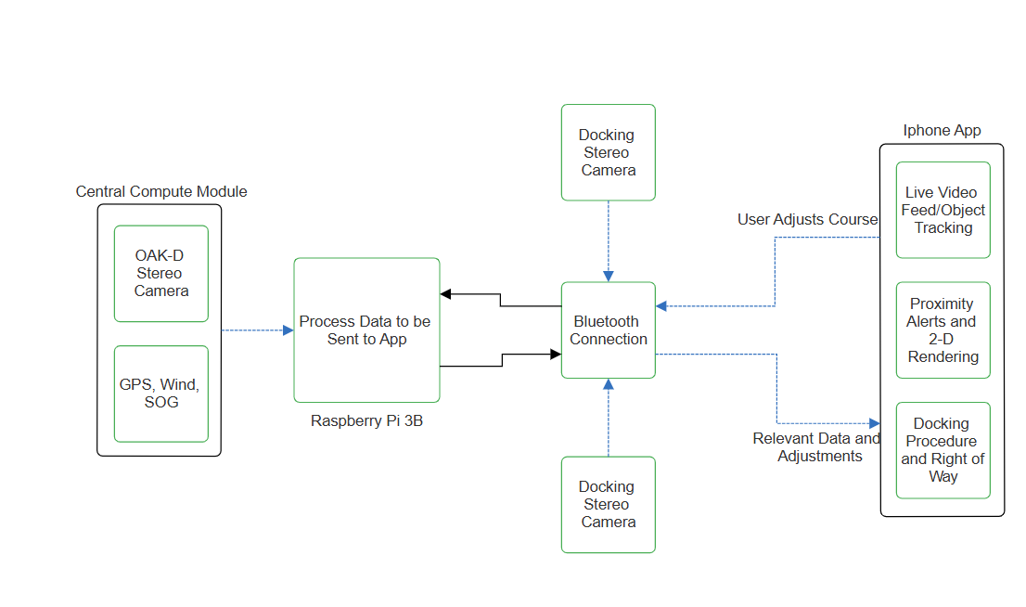
Figure 2.1 The Triton will collect data from the various external sensors and will have their data compiled on a Raspberry Pi 3B. This data will then be sent to the iOS application on the user’s iPhone via Bluetooth Low Energy.

User interface.

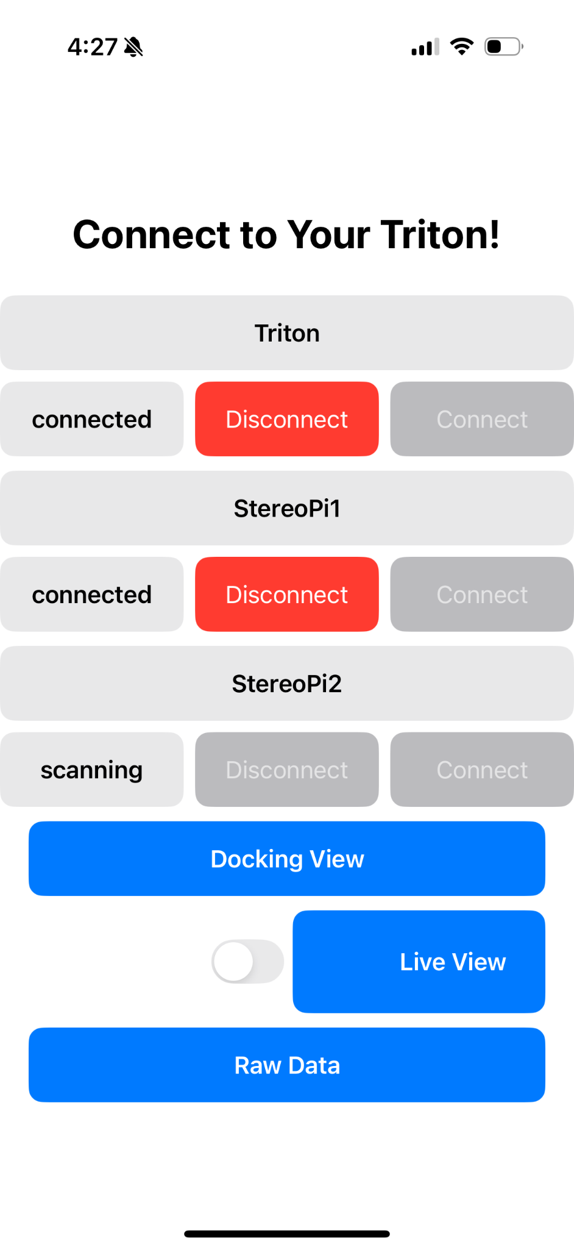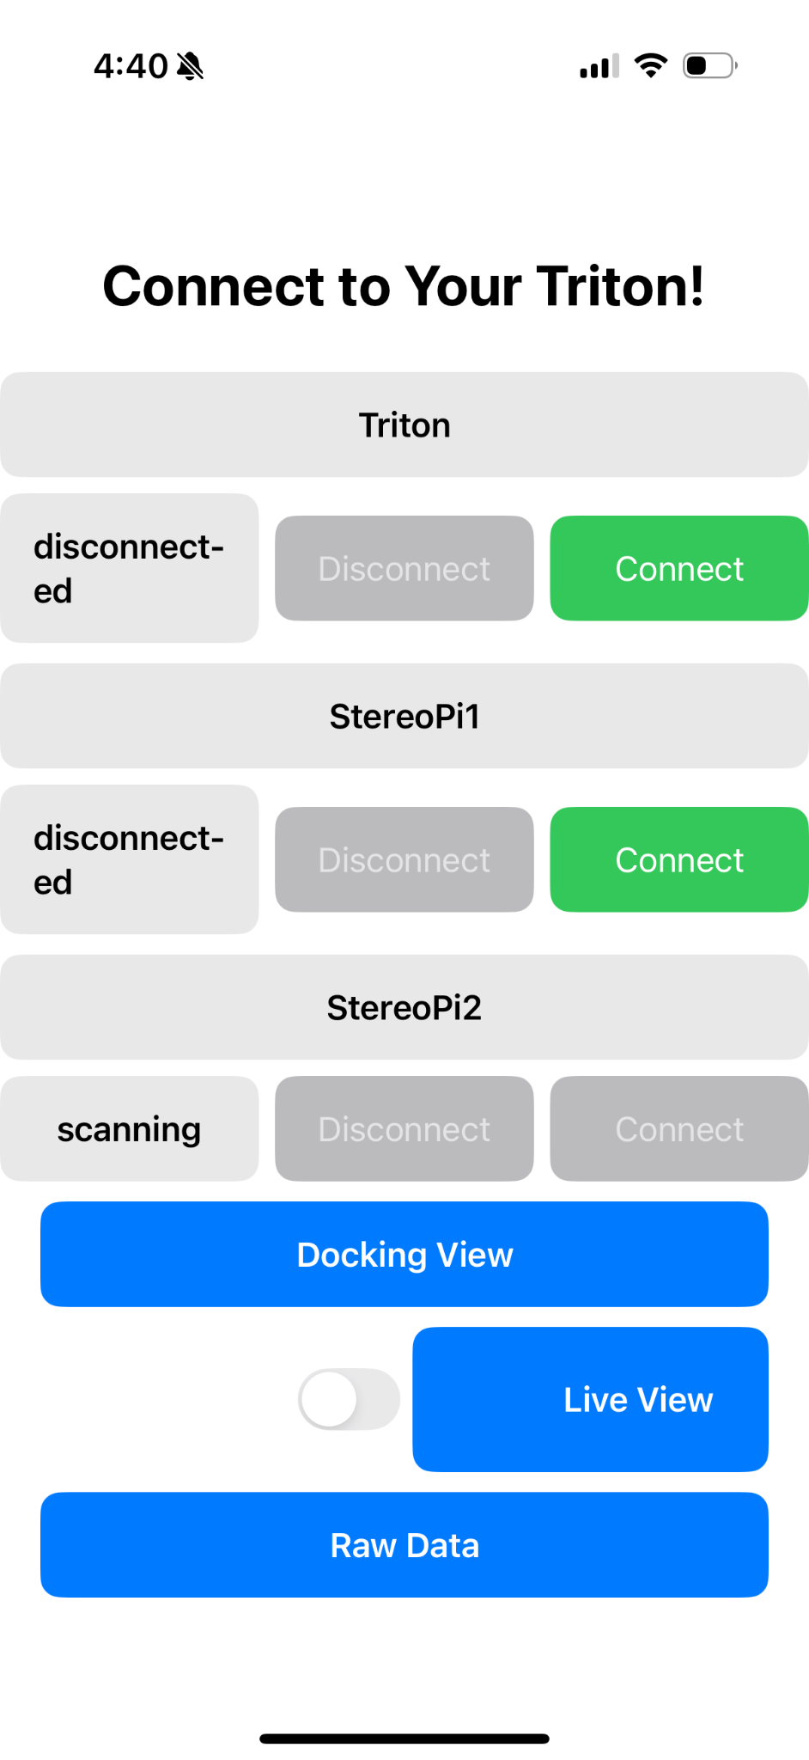
Figure 2.2 The iOS application will feature different tabs with the data collected and will have dedicated pages for specific features. The Docking View will show the polar map rendering of the distance data collected by the stereo cameras on the front and sides of the ship. The live view will display an image taken by the camera on the front of the ship, and this feature will be toggleable via the switch to the left of the ‘Live View’ button. The Raw Data is a page that will display all of the data collected by the GPS and anemometer sensors in one location. Additionally, the user will be able to control when the application connects with the system, as seen on the top of the screen.

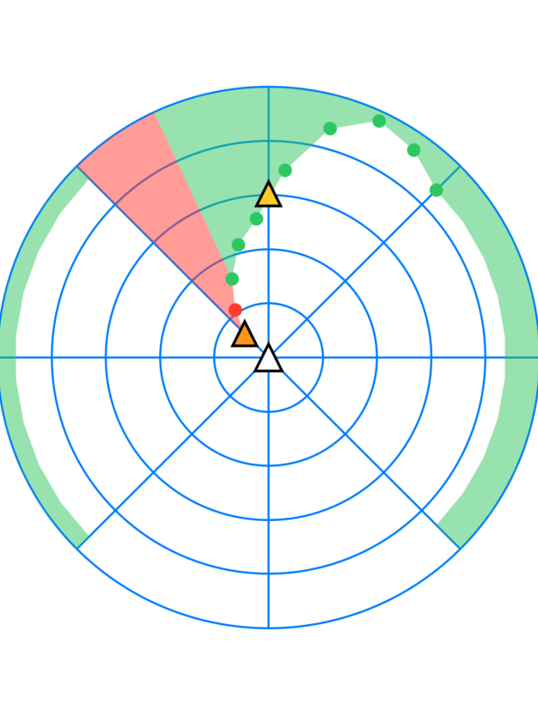
Figure 2.3 The rendering of the depth data will be translated into a polar map. The OAK-D camera at the front of the ship will have a detailed view of the depths as a result of its more advanced capabilities. The side cameras will be represented through a solid bar registering the depths. If an object is too close the region becomes shaded red as a warning. Finally, when the OAK-D recognizes boats, they appear as colored triangles on the mapping.

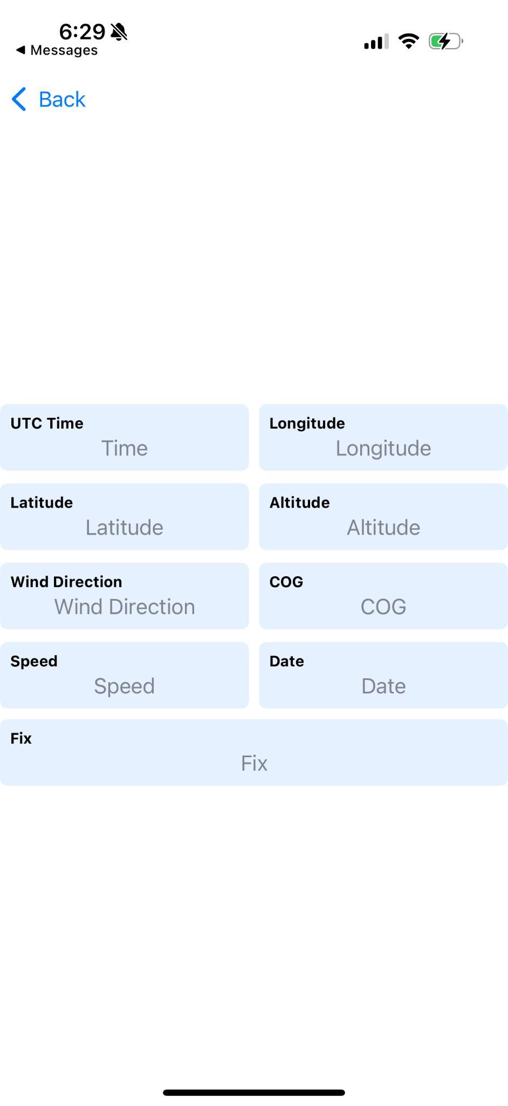

Figure 2.4 The Raw Data page displays the data collected from the anemometer and GPS modules on its own dedicated page.

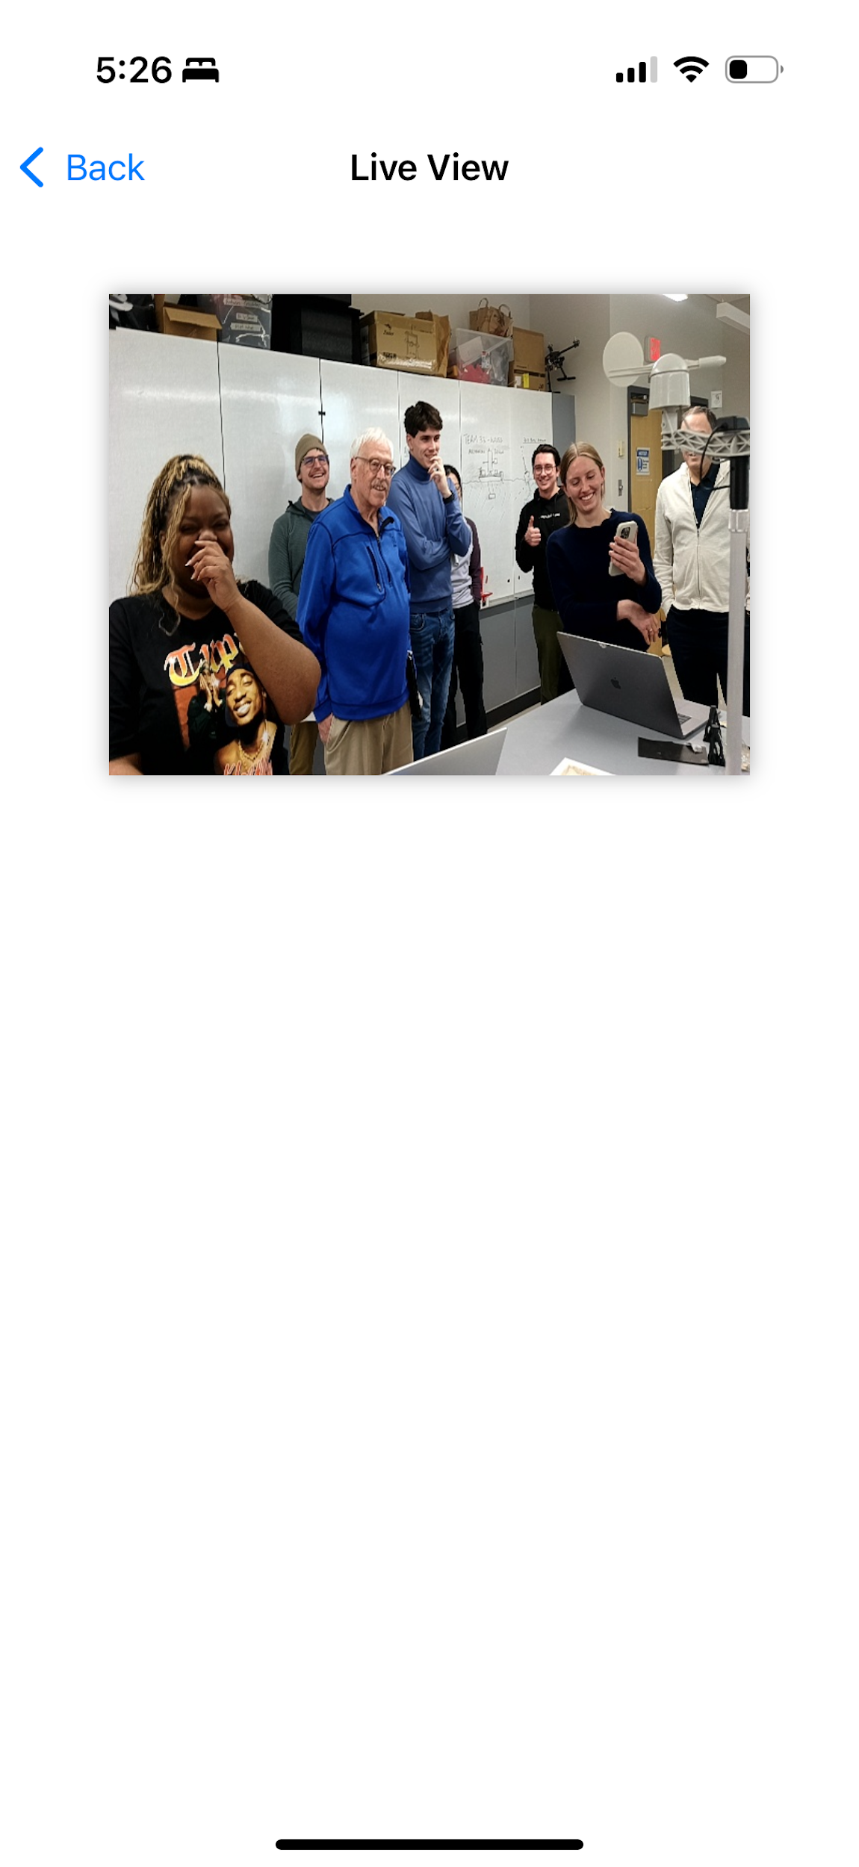
Figure 2.5 Live view page displays the most recent image taken and uploaded from the OAK-D Camera

Physical description.

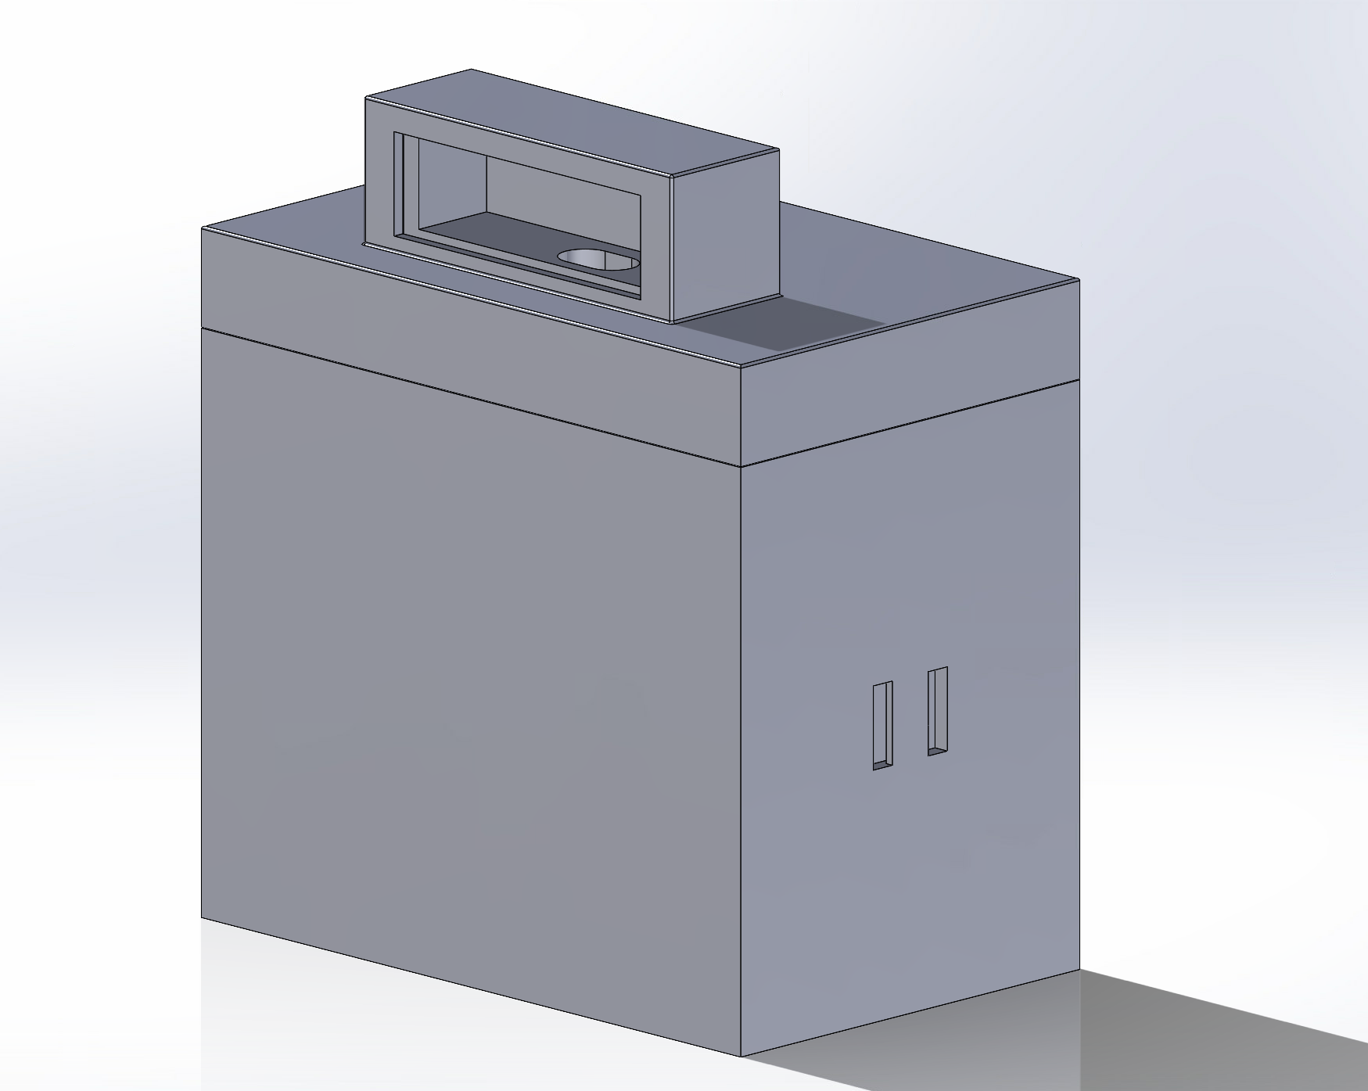
Figure 2.6 Housing for the OAK-D, Raspberry Pi 3B, Anemometer, and GPS on the front of the vessel

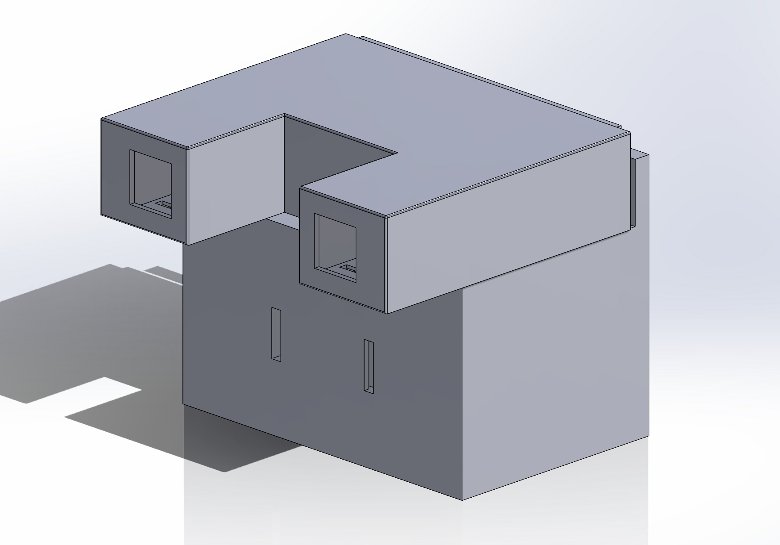
Figure 2.7 Housing for the Raspberry Pi cameras on the side of the vessel

Installation, setup, and support

Software Installation and Setup:
- Download XCode onto a Mac
- Pull from the Senior-Design-Sailboat-Nav-2025 github repository onto the mac
- Open the Triton .xcodeproj found in the Senior-Design-Sailboat-Nav-2025 in XCode
- Connect your iOS device to the Mac via a serial cable (USB-C to USB-C or USB-C to lightning), and make sure to trust the Mac when prompted on the iOS device
- Enable developer mode on your iOS device (https://developer.apple.com/documentation/xcode/enabling-developer-mode-on-a-device)
- Attempt to Launch the app by pressing the arrow button in the top left corner of the XCode window, it will take some time to copy the cache, and then it will fail
- When it fails, go to Settings → General → VPN & Device Management and you will see under the developer app the signature of the app, in this case ‘kylawilson5@icloud.com.’ Click the signature and trust the developer
- Now that you’ve trusted the developer, go back into XCode on your Mac and press the arrow in the upper left corner again, and the app should launch!
- You may disconnect the cable connecting the iOS device to the Mac, and the app will remain on your device until it is deleted

The Triton is composed of three individual sensor modules that contain stereo cameras and other sensors to relay data to the user. These modules will be placed within mounts that the user will need installed at designated locations on their ship the first time they use this product.
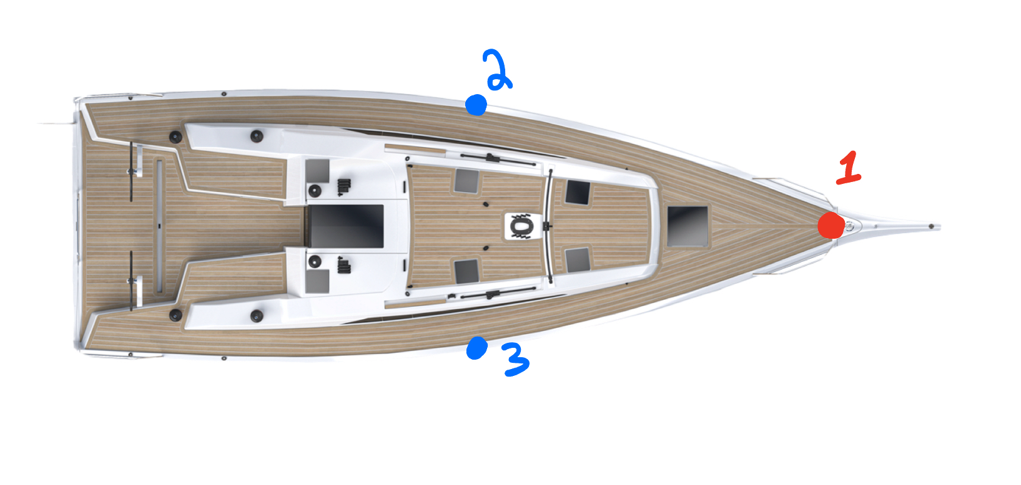
Figure 2.8 Mounting points for the sensor modules around the ship. The main system is to be installed on the front of the ship (1) with the smaller systems on the side (2 & 3)

The mounts will be installed by attaching and tightening the hose clamps and velcro straps on the front railing and lifelines (side railings), with the main system being mounted on the front railing. Once the mounts are installed, the user will turn on the device and place the sensor modules within the mounts. When the modules are securely placed within their mounts, the user will then lock the latches to ensure the stability and security of the devices. They will then open the iOS application and connect to the devices to begin receiving data. Before use, the user will need to have the Triton application installed and their Bluetooth connection actively enabled so that the signal from the sensor modules may be discovered and connected to. With Bluetooth enabled, the user should see the ability to connect to the various devices as seen in Figure 2.2 and begin receiving the modules’ data. When the user is finished sailing, they can close the application and unlock the sensor modules from the latches and take them off the ship or below deck to be recharged.

Hardware Installation and Setup:

The Triton is composed of three individual sensor modules that contain stereo cameras and other sensors to relay data to the app. These modules are placed within semi-permanent mounts that the user must install at specific locations on their ship prior to first use. (see Figure 2.8)

Initial Installation
- Using a flathead screwdriver, attach and tighten the hose clamps of the central module to the railing at the bow of the boat, ensuring the camera is facing away from your ship. (Position 1 in Figure 2.8)
- Wrap the velcro on the sides of the module around a portion of the railing so that it is taut and attach the remaining slack to the velcro attached to the module. For best security, wrap it around the pole at least two times.
- Using the flathead screwdriver, attach and tighten the hose clamps of the side modules to lifelines(side railings) at or close to the widest part of your boat. (Left module Position 2 and Right module Position 3 in Figure 2.8)
- Make sure to push down on both side modules to ensure the suction cups on the bottom of the modules are attached.
- Tighten or loosen the attached velcro so that it is snug against the lifeline pole and attach the remaining slack to itself.

Before Every Use
- Connect the battery pack to each of the modules to power on the devices.
- Place each module in their respective mounted frames, making sure the modules are fully sealed to the frames.
- Place the buckle on the module on the latch attached to the frame and turn the latch so that it is in a horizontal position.
- For best readings, raise the telescoping pole attached to the anemometer, wind vane, and GPS antenna by twisting the metal adjuster to the left to loosen and raise the pole then twisting the adjuster to the right to tighten and lock the position of the pole in place.
- Launch the iOS application and connect to the modules

Operation of the Project

Operating Mode 1: Normal Operation

When in normal operation mode, all software and hardware should already be installed and set up. The user opens the Triton app, and once the services from the devices are discovered, the user will be prompted to connect to each of the individual modules. Each module can be connected or disconnected independently using the corresponding connect and disconnect buttons. Once all modules are connected, the data will begin sending and updating continuously. As seen in Figure 2.2, the user has three options for navigating through the application. If the user selects “Docking View,” the app will display a polar map of the distance data collected by the stereo cameras (see Figure 2.3). If “Raw Data” is selected, the user will be taken to a page that shows the time, longitude, latitude, altitude, wind direction, wind speed, course over ground, speed over ground, date, and whether the GPS has a fix (see Figure 2.4). On the main page of the application, the user can toggle the live view on or off using a switch to the left of the “Live View” button. When toggled on, the app will show updated images from the Oak-D camera mounted on the front of the boat every thirty seconds. Each of these pages includes a back arrow in the top left corner of the screen that will return the user to the main page.
There are some expected behaviors based on specific user actions. If the devices are not powered on, or if the user opens the app while out of range, the app will continue scanning for the devices. In this case, the Docking View page will display a full red ring around the vessel on the polar map. If a device was previously connected but has since disconnected, the Live View page will show the last image received. If there has never been a connection, the page will display “No Image Found.” The Raw Data page will still appear as shown in Figure 2.4, though the displayed values may be blank or outdated until reconnection occurs.

Operating Mode 2: Abnormal Operations

For the rendering, the graph is generated using data received from the OAK-D and StereoPi cameras. Each camera has a maximum range of detecting distances consistently. The rendering anticipates a maximum distance of fifteen meters away and has internal logic to correct if a distance value is greater than fifteen but less than an arbitrary near-infinite distance (when there is nothing present). If an error occurs and a distance of eighteen is read, for example, the point representing that distance may appear above the furthest radial circle on the map, and the shading of the region will be inverted. If this occurs, it will still be an accurate representation of detected distances and will most likely be fixed as the next update of data points is received.
In a similar manner, the StereoPi cameras placed on the sides of the ship are sometimes prone to generating random noise which can potentially cause some inconsistencies in the depth readings. However, this noise is very brief and will not last after the data is updated, like the rendering.
The wind vane may randomly have a spike in voltage due to noise that gives the wrong resistance correspondence and therefore an incorrect angle and direction. However, in software filtering is used to prevent this from happening most of the time.
The OAK-D’s object recognition model may occasionally detect an additional “ghost” object if two or more objects rapidly overlap with one another. The OAK-D will then give the user false readings on the third ghost object. Similarly if an object quickly leaves the frame, the model may also display a ghost object of where the object was last detected. The OAK-’s software is capable of detecting these ghost objects and removing them after only a few frames.

Safety Issues

With this project being heavily reliant on electronic equipment in a marine environment there is an inherent safety concern for the product with water damage. The system is waterproof, however if the integrity of the housing is compromised, then there is a chance of water damage to occur. One mitigation technique would be to cover, dry, or drain out the mounting pieces if they are left out in the rain before installing the module frames.
For user safety, it is vital to use this product as a secondary assistance and not a primary method of docking. A sailor’s view may be impaired or their “boat sense” of how far they are may be weak and that is when this product is most necessary. A sailor should not rely only on the rendering and data collected to approach a dock or navigate through a harbor. Additionally, the system can be used if the sailor needs to go below deck for any reason, but with the short range of the cameras and the slower upload time of the live view images, it is not recommended to be away from the helm for too long. This system may not be able to warn a sailor in time of an oncoming obstacle.

Technical Background

The Triton uses several technologies to give sailors insights into the conditions around them at their fingertips.

Bluetooth Low Energy (BLE)
The Triton uses Bluetooth Low Energy as the main form of communication between modules placed around different parts of the boat. These modules include:
- Main Module
  - Raspberry Pi, Oak-D, Anemometer, Wind Vane, GPS
- Peripheral Module (x2)
  - Raspberry Pi CM4, StereoPi v2, Raspberry Pi Camera (x2)
- iOS Device
The Raspberry Pi, the Raspberry Pi CM4, and the iOS devices all have RF transponders, which allow the devices to send and receive data wirelessly, enabling Bluetooth functionality. Bluetooth Low Energy is specifically designed for low-power systems. Bluetooth Low Energy (BLE) is a wireless communication protocol designed for low-power, short-range data exchange between devices. It operates in the 2.4 GHz ISM band and uses a simplified protocol stack compared to classic Bluetooth to reduce energy consumption. BLE communication is based on a client-server model, where a central device (iOS device) connects to a peripheral device (main housing, peripheral housing) to read or write data. Data is organized into attributes and grouped into services, which are accessed using the Generic Attribute Profile (GATT). BLE uses advertising packets to allow peripherals to broadcast their presence, enabling quick and efficient connection setup.

Stereo Vision (Oak D and StereoPis)
The Triton has three independent stereo cameras providing the user 270 degrees of coverage. Stereo cameras consist of two cameras placed a set distance apart which each capture slightly different images. The pixel value differences between these two images can be used to create a disparity map. The inverse of these disparities can then be used to calculate the distance of an object from the camera, allowing for fast and accurate distance readings. These distance readings are used to keep track of how close an object is to the boat, and allows for accurate advice to be sent to the user regarding what would be the wisest action given their current environment.
Although the Oak-D’s cameras come already pre-calibrated, the StereoPis were designed to work with any type of boat, as well as maximize its measuring distance such that warnings can be made for more situations.
The OAK-D’s object detection system consists of two parts: a general depth map and a YOLOv4 object recognition model. The general depth system uses the depth map created by the camera and then overlays a 10x10 grid of regions of interest or ROI’s. The depth is then recorded and the ROI cell with the closest recorded distance in each column is then sent and displayed to the app. The object recognition system can detect and recognize most maritime vessels and draws an ROI around each vessel. The ROI relays the vessel's relative position to the boat and its distance when within 15 meters. The model is capable of identifying vessels within 30 - 50 meters depending on their size.

Swift and SwiftUI
Swift is a powerful programming language developed by Apple for building applications across iOS, macOS, etc. SwiftUI is a framework that allows developers to design user interfaces using declarative syntax. With SwiftUI, the UI is automatically updated when the underlying data changes using Observed Objects, simplifying state management. The team used SwiftUI to create the entirety of the UI, including the application, polar rendering, raw data page, and live view. Similarly, the underlying Bluetooth management and data transfer are managed in Swift using Apple’s CoreBluetooth framework. Swift and SwiftUI communicate seamlessly with each other.

D-Bus
D-Bus is an inter-process communication (IPC) system in Linux that allows applications and system components to communicate with one another. In the context of the BlueZ stack, D-Bus serves as the primary interface for interacting with low-level Bluetooth devices and services in Linux. BlueZ exposes the device’s Bluetooth functionalities, such as device discovery, pairing, and GATT operations through a set of well-defined D-Bus APIs. The Bluetooth applications running on the Raspberry Pi in the main housing and the Raspberry Pi CM4s in the peripheral housing use these APIs to monitor Bluetooth events and control Bluetooth behavior without directly interacting with low-level kernel modules.
D-Bus was also used to enable cross-application/cross-script IPC, where unique D-Bus services were created. These services register custom objects and interfaces on D-Bus, which the Bluetooth scripts invoke using method calls. We implemented these custom D-Bus services in Python and C++ and registered it with the D-Bus daemon. This IPC mechanism provides a flexible and standardized way to communicate between the scripts that collect useful data like GPS data, anemometer data, and Oak-D data and the script that makes this data available to the iOS application, the Bluetooth script.

Anemometer and Wind Vane
The anemometer measures wind speed using a cup-type sensor that closes a magnetic reed switch each time a magnet rotates past it. A wind speed of 2.4 km/h causes the switch to close once per second, allowing wind speed to be calculated by counting pulses over time using a microcontroller or digital counter. Wind direction is determined by a wind vane containing eight switches, each connected to a distinct resistor. Depending on the vane’s orientation, one or two switches are closed, producing up to 16 unique resistance values corresponding to specific directions in 22.5° increments. These resistors form a voltage divider, and the resulting analog voltage is read by a 16-bit analog to digital converter where the corresponding resistance is determined to get the wind direction.

GPS
The Global Positioning System (GPS) is a satellite-based navigation system that provides location, speed over ground, and time information to receivers anywhere on Earth. It operates by using a network of satellites that continuously transmit signals containing their position and time. A GPS receiver calculates its position by triangulating signals from at least four satellites, three that determine the GPS’s precise location, and one that adjusts for the error in the GPS’s clock. This allows the receiver to compute its three-dimensional position (latitude, longitude, and altitude) and synchronize its clock to Coordinated Universal Time (UTC).
The GPS receiver outputs data in the form of NMEA (National Marine Electronics Association) sentences, which are standardized ASCII text strings. These sentences allow us to get important navigation information such as position (GGA), time and date (RMC). Each NMEA sentence begins with a “$” and includes a checksum for validation, which makes it easy for us to parse and extract data from.

Relevant Engineering Standards

The Triton is a maritime device, thus it is made to be waterproof with a rating of IP-66 utilizing PETG filament and flex seal. It utilizes expert advice in order to guide the user on how to properly dock their boat as well as warn if the sailor may be docking incorrectly. Additionally, the device will provide advice on right of way rules for open sailing that fall under the Convention on the International Regulations for Preventing Collisions at Sea (COLREGs) standards. The app was created utilizing SwiftUI, and thus follows the protocol for Apple applications, while the sensors were programmed in Python for ease of interaction when it comes to Bluetooth. The images that come from the Oak-D are screenshots that are taken after twenty-five seconds, to maximize efficiency while giving the sailor an up to date view of the front. Data from each sensor is transferred to the central system as well as the app via Bluetooth. The app then processes and presents the user with the relevant data and warnings. The type of Bluetooth used is Bluetooth Low Energy and Bluetooth 5 for high efficiency data transfer.
The total system is powered by three lithium battery packs and a simple circuit board. The battery packs were tested for their safety under the IEC 62133 standards, which ensures the safety and performance of portable batteries. In addition to this, the use of GPS maintains best practices based on the GPS Standard Positioning Service (SPS) Performance Standard.

Cost Breakdown

Project Costs for Production of Beta Version (Next Unit after Prototype)
Item | Quantity | Description | Unit Cost | Extended Cost
1 | 1 | GPS module | 24.99 | 24.99
2 | 2 | StereoPi Slim V2 | 59.95 | 119.90
3 | 2 | RPiCM4 with Bluetooth | 35 | 70
4 | 1 | OAK-D S2 | 250 | 250
5 | 1 | Anemometer and Wind Vane | 79.95 | 79.95
6 | 1 | 60,000 mAH Battery Pack | 39.88 | 39.88
7 | 2 | 30,000 mAH Battery Pack | 31.19 | 62.38
8 | 1 | Coupler | 1.84 | 1.84
9 | 1 | 16 Bit ADC | 14.95 | 14.95
10 | 1 | RJ11 connector cable | 1.46 | 1.46
11 | 1 | Telescoping Pole for Anemometer | 27.00 | 27.00
12 | 2 | Liquid Tight Plastic Adapter | 3.98 | 7.96
13 | 1 | Rubber Washers | 12.98 | 12.98
14 | 2 | Flex Seal | 16.98 | 33.96
15 | 1 | Flange Mount | 8.98 | 8.98
16 | 10 | Latches | 4.84 | 48.40
17 | 2 | PETG Filament | 16.99 | 33.98
Beta Version-Total Cost |  |  |  | 838.61

The budget can be separated into two key portions: the hardware for the modules and the materials necessary for the assembly of the product. The devices make up a large portion of the budget despite there being more total materials for the assembly of the product. Despite this, though, the price of the beta version of the product is still very reasonable, considering most maritime sensor systems tend to be upwards of $1000 with less functionality and incompatible with certain boat types. Our product will work on boats with railings and provide multiple different data types.

Appendices

Appendix A - Specifications

Requirement | Value, Range, Unit
Dimensions | Main: 8.75” x 5.5” x 9.96” *  Peripheral: 5.75” x 6.2” x 5.1”
Weight | < 25lbs
Weatherproofing | IP66
Update Speed | Every second**
Depth Detection Range | 15 meters
Object Detection Range | 30-50 meters
Battery Life | 12 hours
GPS Accuracy | within 5 meters
*: without anemometer
**: for anemometer and GPS Data

Appendix B – Team Information
Team 25, SailNav, was composed of four computer engineers and one dual major computer and mechanical engineer. The idea of a product that could be mounted onto a sailboat to assist with docking was proposed by Ryan Lagoy, who served as the team’s client, and the Triton was the team’s interpretation, design, and implementation of this idea.
Kyla Wilson is a computer engineer who will be moving to Chicago and working as a Firmware Engineer for Bayer, Crop Science upon graduation. Kyla was responsible for all of the integration and IPC for the Triton, enabling and managing Bluetooth Low Energy for each of the modules, and creating and managing the iOS application’s UI.
Leyandra Burke is a graduating computer and mechanical engineer with an interest in product development and manufacturing. Leyandra was responsible for the implementation of the GPS and anemometer and wind vane sensor modules. She was also responsible for the housing design, production, machining, and waterproofing.
Diego D’Angelo-Cosme is a graduating computer engineer who is aspiring to enter the tech industry after graduating. He has a passion for rapid prototyping, code design and review, and networking and cybersecurity topics. For the Triton, Diego was chiefly responsible for developing the rendering of cameras’ data and creating the power budget for the system.
Kevin Connell is a computer engineer graduating with a strong interest in computer hardware and architecture. Hoping to continue designing and optimizing on the hardware level. Kevin was responsible for the Triton’s primary stereo camera the OAK-D and developing the system of detecting vessels and recording their distance and position.
Matthew Guacho is a computer engineer who has an expertise and interest in software engineering. With a particular expertise in algorithms, he strives in making projects efficient. Matthew was responsible for coding and calibrating the side StereoPi cameras, as well as maximizing the distance the cameras can read.

